Project Planning Phase
Project Planning Template (Product Backlog, Sprint Planning, Stories, Story points)
Date | 15 February 2025
Team ID | SWTID-2026-6425
Project Name | EduGenie – AI-Powered Learning Assistant
Maximum Marks | 5 Marks

Product Backlog, Sprint Schedule, and Estimation (4 Marks)
Use the below template to create product backlog and sprint schedule
Sprint | Functional Requirement (Epic) | User Story Number | User Story / Task | Story Points | Priority | Team Members
Sprint-1 | Question Answering | USN-1 | As a user, I can enter a question and receive an AI-generated answer. | 2 | High
Sprint-1 |  | USN-2 | As a user, I can receive a clear response for a valid question through the EduGenie interface. | 1 | High
Sprint-1 | Topic Explanation | USN-3 | As a user, I can enter a topic and receive an AI-generated explanation. | 3 | High
Sprint-1 | Quiz Generation | USN-4 | As a user, I can generate a quiz with three questions, four options, correct answers and explanations. | 3 | High
Sprint-1 |  | USN-5 | As a user, I can validate and review the generated quiz result. | 3 | Medium
Sprint-2 | Text Summarization | USN-6 | As a user, I can submit study text and receive a concise summary. | 2 | High
Sprint-2 |  | USN-7 | As a user, I can view the generated summary in the EduGenie result area. | 2 | High
Sprint-2 | Learning Path | USN-8 | As a user, I can provide a topic and learner level for a personalized learning path. | 2 | High
Sprint-2 |  | USN-9 | As a user, I can receive structured stages, key concepts, timeline and milestones for the learning path. | 4 | High
Sprint-2 |  | USN-10 | As a user, I can receive practice/projects and resource guidance for the learning path. | 5 | Medium
Sprint-2 | Learning Interface & Integration | USN-11 | As a user, I can access the learning features and view their generated results through one integrated interface. | 5 | High

Project Tracker, Velocity & Burndown Chart: (4 Marks)
Sprint | Total Story Points | Duration | Sprint Start Date | Sprint End Date (Planned) | Story Points Completed (as on Planned End Date) | Sprint Release Date (Actual)
Sprint-1 | 12 | 6 Days | 17 Feb 2025 | 22 Feb 2025 | 12 | 22 Feb 2025
Sprint-2 | 20 | 6 Days | 24 Feb 2025 | 01 Mar 2025 | 20 | 01 Mar 2025

Velocity:
Following the supplied planning logic, velocity is calculated from the total story points completed divided by the number of sprints.
Total Story Points = 12 + 20 = 32
No. of Sprints = 2
Velocity = 32 / 2 = 16 Story Points per Sprint
Your team’s velocity is 16 Story Points per Sprint.
Burndown Chart:
A burn down chart is a graphical representation of work left to do versus time. For EduGenie, the planned work starts at 32 story points, reduces to 20 after Sprint-1, and reaches 0 after Sprint-2.
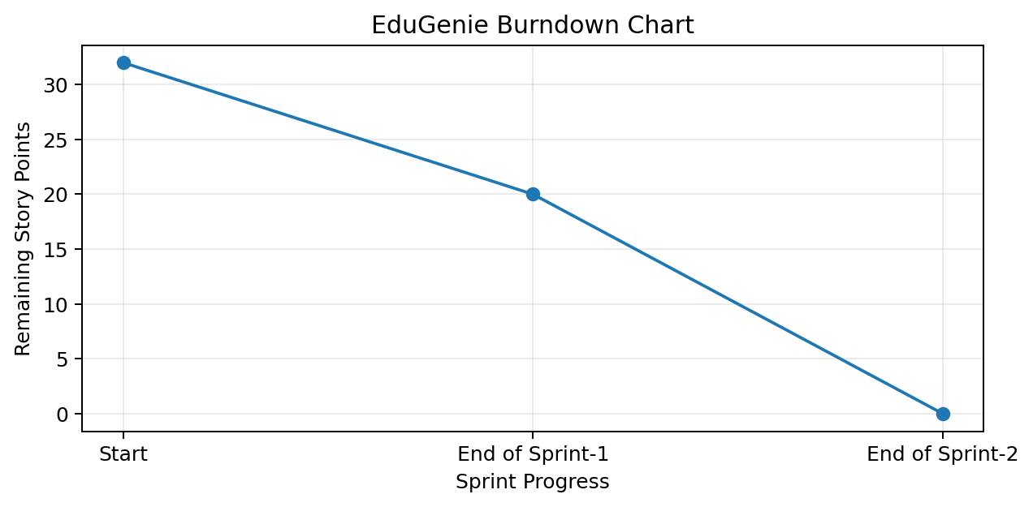

Reference: Planning logic supplied for Sprint, Epic, Story, Story Point and Velocity calculation.

